**Copyright**

When collecting assets for my game I need to be aware of copyright and other legislation before using them and I need to abide by conditions of use.

Copyright is the exclusive and assignable legal right, given to the originator for a fixed number of years, to print, publish, perform, film, create, or record literary, artistic, musical and other media.

This means that if someone owns an image that I want to use I have to get permission. However, some images are part of the public domain that anyone can use free of charge.

All of the sounds that I am using for my game are from Zapsplat.com and require credit given to the website. Zapsplat.com is a great resource because it is all free.

**Creative commons**

There are six different license types, listed are the four most permissive:

* **[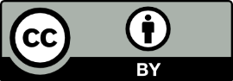](https://creativecommons.org/licenses/by/4.0/)**[**CC BY**](https://creativecommons.org/licenses/by/4.0/)**:**This license allows re-users to distribute, remix, adapt, and build upon the material in any medium or format, so long as attribution is given to the creator. The license allows for commercial use.

CC BY includes the following elements:  
BY  – Credit must be given to the creator

 What this means: product may be used as long as credit is given to the recorded creator. The product may also be changed if credit is given and permission is granted by the creator.

* **[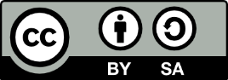](https://creativecommons.org/licenses/by-sa/4.0/)**[**CC BY-SA**](https://creativecommons.org/licenses/by-sa/4.0/): This license allows re-users to distribute, remix, adapt, and build upon the material in any medium or format, so long as attribution is given to the creator. The license allows for commercial use. If you remix, adapt, or build upon the material, you must license the modified material under identical terms.

CC BY-SA includes the following elements:  
BY  – Credit must be given to the creator  
SA 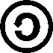 – Adaptations must be shared under the same terms

 What this means: this is same as the above license except that you need to licence the edited product under the same conditions as the original.

* **[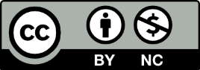](https://creativecommons.org/licenses/by-nc/4.0/)**[**CC BY-NC**](https://creativecommons.org/licenses/by-nc/4.0/): This license allows re-users to distribute, remix, adapt, and build upon the material in any medium or format for non-commercial purposes only, and only so long as attribution is given to the creator.

It includes the following elements:  
BY  – Credit must be given to the creator  
NC  – Only non-commercial uses of the work are permitted

What this means: the product may be changed as long as no money is made from the adaption and that credit has to be given by the creator.

* **[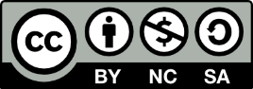](https://creativecommons.org/licenses/by-nc-sa/4.0/)**[**CC BY-NC-SA**](https://creativecommons.org/licenses/by-nc-sa/4.0/): This license allows re-users to distribute, remix, adapt, and build upon the material in any medium or format for non-commercial purposes only, and only so long as attribution is given to the creator. If you remix, adapt, or build upon the material, you must license the modified material under identical terms.

CC BY-NC-SA includes the following elements:  
BY  – Credit must be given to the creator  
NC  – Only non-commercial uses of the work are permitted  
SA  – Adaptations must be shared under the same terms

What this means: This means that credit must be given to the creator but permission does not have to be granted. Only non-commercial uses are permitted, so money can be made. The work also has to be shared under the same conditions.

**How this applies to me:**

Because this project is for educational purposes I do not need to worry about legal aspects, however if this was for a real contract then I would either have to make images myself or find them royalty free. I could also buy images or give permission as is in the case of most of the licenses above.

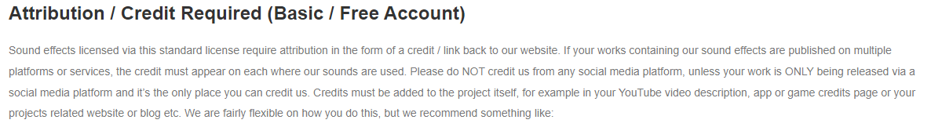In the case of sounds, these are the conditions set by zapsplat: